[Egyptian Journal of Basic and Applied Sciences 4 (2017) 22–29](http://dx.doi.org/10.1016/j.ejbas.2017.01.002)

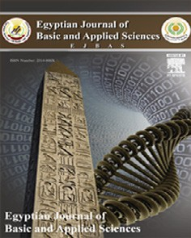

Contents lists available at [ScienceDirect](http://www.sciencedirect.com/science/journal/2314808X)

Egyptian Journal of Basic and Applied Sciences

journal homepage: [www.elsevier.com/locate/ejbas](http://www.elsevier.com/locate/ejbas)

Full Length Article

Skin pattern structure and function of juvenile ages of *Chameleo chameleon*



Yosra A. Fouda a,b, Ahmed A. El Mansi a,⇑

a *Zoology Department, Faculty of Science, Mansoura University, Mansoura, Egypt*

b *Biology Department, Faculty of Science and Arts, Qilwah, Baha University, Saudi Arabia*

# a r t i c l e i n f o

*Article history:*

Received 13 November 2016

Received in revised form 5 January 2017 Accepted 7 January 2017

Available online 19 January 2017

*Keywords:*

*Chameleo chameleon*

Skin Melanosomes

Electron microscopy Immunohistochemistry

# a b s t r a c t

Little is known about the skin structure of juvenile chameleon especially its sensory function of their integumentary structure. Fifteen juvenile *Chameleo chameleon* are collected from Abu Rawash, Northern area of Giza, Egypt during Summer of 2015. It is belong to the order Squamata, family, Chamaeleonidae. Three ages are used in the present study and categorized according to the morpholog- ical criteria of head, abdomen and limb lengths. Dorsal abdominal surfaces are covered with abdominal scales of varying sizes either conical or elliptical-structures, regularly arranged in rows and imbricated with each other. Each scale possessed one cylindrical lenticular epidermal sense organ containing heavy sensillia. Histologically, the scales are characterized by wider conical surfaces and intermingled with another one by hinge region. The epidermal layer of outer scale surface is composed of five-layered strat- ified squamous epithelium including the stratum germinativum, intermediate zone of stratum spinosum

and granulosum, a-keratin layer, b-keratin layer and outer superficial Oberhaütchen. Melanosomes are

abundant in the intermediate zone as well as in the peripheral dermal layer underneath stratum germi- nativum layer. The melanosomes possessed long cellular processes with their content of melanin gran- ules underneath the epidermis. The dermis is composed of upper collagenous and inner compact layer. Semithin sections revealed the presence of fibroblast cells, collagenous fibrils, nerve axons, melanosomes and mast cells in the connective tissue core. Increased immunoreaction of cytokeratin is observed in the epidermal layers of G3; meanwhile, an increased proliferation of epidermal and dermal cells was detected in G1. Transmission electron microscopy exhibited striking formation of dermal sense organs containing neuronal cells of both oligodendrocytes and Schwann cells with myelinated and unmyelinated nerve axons ensheathed externally by thin collagenous fibers. Finally, the author concluded that the juve- nile chameleon skin is keratinized with obvious external and internal sensation and abundant mast cells within dermis giving characteristic immunity. The melanosomes are dispersed within epidermis and der- mis allowing the animal to maintain its color alterations according to the surrounding environment.

© 2017 Mansoura University. Production and hosting by Elsevier B.V. This is an open access article under

the CC BY-NC-ND license (<http://creativecommons.org/licenses/by-nc-nd/4.0/>).

1. Introduction

Squamata possessed varying skin structures. As a result of living in desert, the hardness of reptilian integument keeps the animal internal organs from damage and dehydration [1].

The scaly covering of epidermis represents the most adaptive function for water retention that maintain flourishing and accom- modation of reptilian for a terrestrial life [2]. Characteristic varia- tions of scale shape, size, and their overlapping are represented in reptilian species [3].

The epidermis mainly composed of five major layers, Ober- haütchen, b-keratin layer, a-keratin layer, intermediate zone and

* Corresponding author.

*E-mail address:* [elmansi@mans.edu.eg](mailto:elmansi@mans.edu.eg) (A.A. El Mansi).

stratum germinativum [4–7]. The stratum germinativum or basale is made up of single layer of highly proliferative cuboidal cells and the source of keratinocytes progenitors [4]. After proliferation of the neo-keratinocytes, it migrates and differentiates along the way to the outer Oberhaütchen. The intermediate zone contains keratinocytes at different developmental stages where lipids and proteins are packaged in granular structures. Later, the lipid envel-

ops are created by releasing the lipid content to form the corneo- cytes of the superficial layer [8]. The a-layer is soft and elastic and has specific connections to the preceding scales and the b-layer, which is relatively hard, forms the surface of the scales [4].

The dermis is mainly composed of connective tissue and colla- gen fibers with many important structures including chro- matophores, lymphatic vessels, nerves and blood vessels [4].

<http://dx.doi.org/10.1016/j.ejbas.2017.01.002>

2314-808X/© 2017 Mansoura University. Production and hosting by Elsevier B.V.

This is an open access article under the CC BY-NC-ND license (<http://creativecommons.org/licenses/by-nc-nd/4.0/>).

The skin of reptilian species varied in their distribution and densities of epidermal melanocytes and dermal melanophores, lipophores, and iridophores [7,9,10]. In Chameleons and some ano- line lizards, the chromatophores represent the main components of a dermal chromatophoric unit in combination with melano- phores [11].

Integumentary sense organs represent the mechanosensory receptors in reptilian species such as *Amphibolurus barbatus* [12] and *Iguanian lizards* [13]. These sense organs serve as mechano and thermoreceptors and possibly sensitivity to humidity [12,13]. It is also served as complex touch corpuscles on the skin surface of the head of snakes [14,15]. Small tactile mechanosensory epi- dermal sense organs are also reported in 13 fully aquatic and two semi-aquatic species of elapids [16].

The present study aimed to illustrate the integumentary neu- roepithelial interaction of juvenile chameleon and its capacity of proliferation through light, immuno and ultrastructural studies.

1. Materials & methods

Fifteen juvenile individuals of *Chameleo chameleon*, Linnaeus (1758) (Class: Reptilia; Order, Squamata; Suborder Sauria; Family, Chamaeleonida; Genus, Chamaeleo; Species, *Chameleo chameleon*) were collected from Abou—Rawash desert, Giza Governorate, Egypt during summer 2015. The specimens were categorized into three stages according to the variations of total body length, head length, tail length, body width and limbs length as represented in Table 1 and Fig. 1.

* 1. *Histological investigation*
     1. *Hematoxylin eosin staining*

Dorsal skin of trunk region of different developing stages is fixed in 10% phosphate buffered formalin (pH 7.4), dehydrated in ascending percentages of ethyl alcohol, cleared in xylene and

mounted in molten paraplast at 58–62 °C. Five lm sections were

cut, stained with hematoxylin and eosin and investigated under a bright field Olympus light microscope.

* + 1. *Immunohistochemical staining of CK and PCNA*

Immunostaining was performed on formalin-fixed and paraffin- embedded tissues. Hydrated tissue sections were firstly incubated in 2% hydrogen peroxide endogenous peroxidase activity for 5 min

to block peroxidases. The slides were then incubated overnight at 4 °C in a humidified chamber with the primary antibodies of cytok- eratin (Cat. sc-25280, 1:50, mouse, Santa Cruz) and PCNA (Cat. sc- 56, 1:400, mouse, Santa Cruz). After rinsing with a phosphate- buffered solution, the specimens were incubated in biotinylated secondary antibody for 50 min at room temperature followed by

treatment with Avidin–Biotin–horseradish peroxidase and staining with 0.04% 3,3'-diamino-benzidine tetrahydrochloride and Hema- toxylin. Negative control was carried out by using the primary antibody.

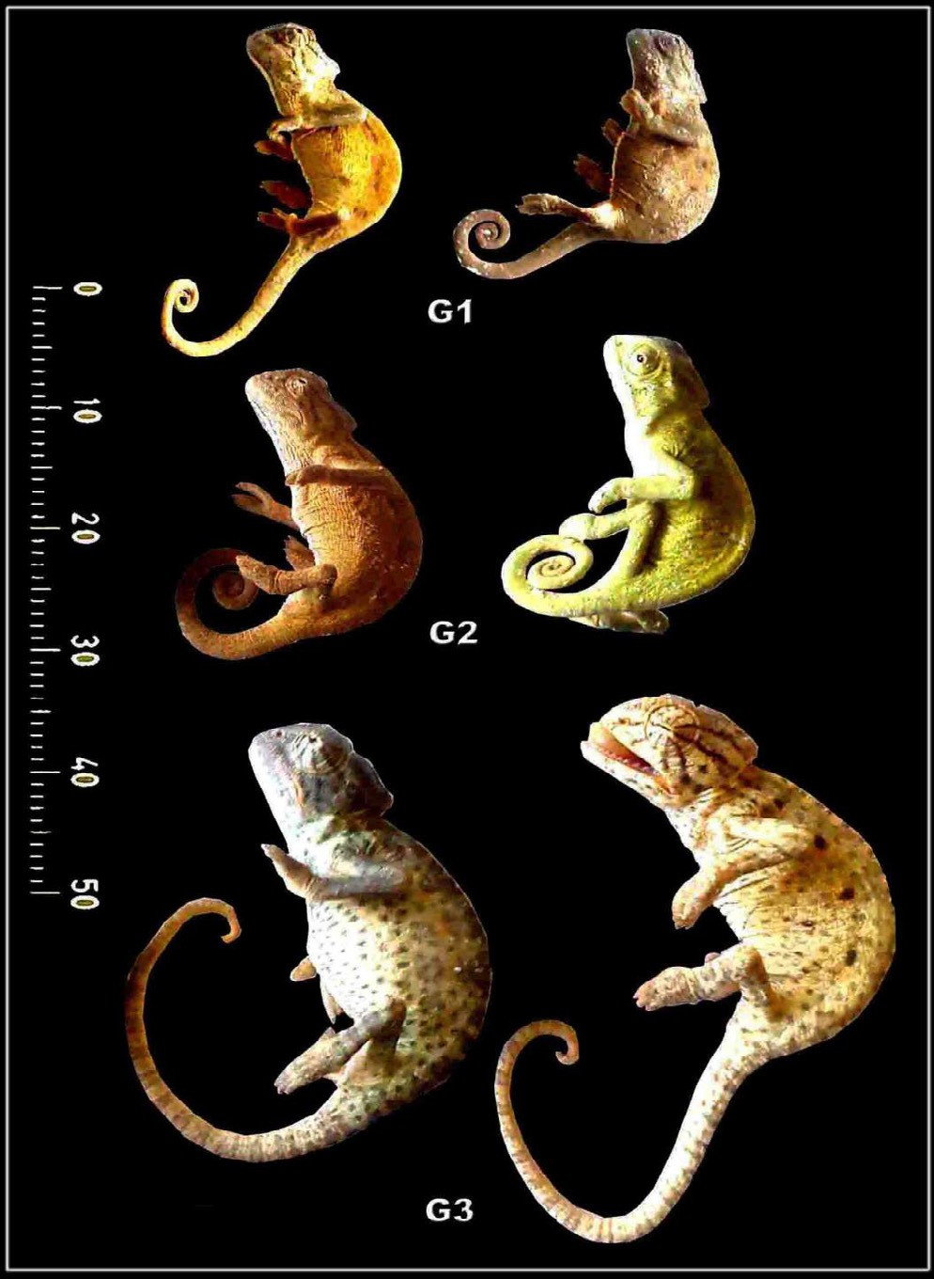

Fig. 1. Lateral view photomacrographs of different stages of developing *Chameleo chameleon.*

* 1. *Scanning electron microscope*

Skin samples were fixed in 2.5% glutaraldehyde in cacodylate buffer. This was followed by dehydration in ascending percentages of ethyl alcohol and critically point drying, and coating with gold in platinum-palladium ion-sputtering and investigating under Jeol scanning electron microscope, JSM-5400LV.

* 1. *Transmission electron microscope*

Fresh samples were fixed in 2.5% glutaraldehyde in cacodylate buffer (pH 7.4, post-fixed in 1% osmium tetroxide, dehydrated in ascending percentages in ethyl alcohol, and cleared in propylene

oxide and embedded in araldite resin and allow for complete poly- merisation at 60 °C. Semithin sections (1 lm) were cut at Ultracut Reichert-Jung ultramicrotome with the aid of glass knives, stained with toluidine blue and examined under light microscope. For elec-

tron microscopy ultrathin sections were carried out, stained with uranyl acetate and lead citrate and examined with a Joel CX 100

Table 1

Morphometric analysis of different developing stages of *Chameleo chameleon* in (*mm*).

|  |  |  |  |  |  |  |  |  |
| --- | --- | --- | --- | --- | --- | --- | --- | --- |
|  | TBL | HL |  | SVL | TL | BW | FLL | HLL |
|  | Antero-posterior | Dorso-ventral |  |  |  |  |  |
| G1 | 10.33 ± 0.65 | 2.72 ± 0.20 | 1.87 ± 0.16 | 6.08 ± 0.57 | 4.90 ± 0.21 | 2.69 ± 0.10 | 2.78 ± 0.33 | 3.37 ± 0.32 |
| G2 | 13.69 ± 0.78 | 3.14 ± 0.17 | 2.22 ± 0.24 | 7.71 ± 0.77 | 6.02 ± 0.46 | 3.12 ± 0.09 | 3.16 ± 0.17 | 3.73 ± 0.25 |
| G3 | 17.56 ± 0.56 | 3.48 ± 0.44 | 2.98 ± 0.21 | 10.51 ± 0.65 | 7.96 ± 0.54 | 3.52 ± 0.22 | 4.17 ± 0.29 | 4.95 ± 0.17 |

Each result represents the mean ± SE (n = 5). Abbreviations; BW, Body width (in the middle of trunk); FLL, For limb length; HL, Head length (from tip of snout to the corner of the neck); HLL, Hind limb length; SVL, Snout vent length; TBL, Total body length; TL, Tail length.

transmission electron microscope operated at an accelerating volt- age of 60 kV.

* 1. *Statistical analysis*

Data were presented as mean ± standard error. The statistical analysis was performed using SPSS (version 18) software package for windows.

1. Results
   1. *Scanning electron microscopy observations*

The selected ages of studied young *Chameleo chameleon* are determined according to the length of fore and hind limb and head length (from tip of snout to the corner of the neck), Snout vent length and whole body length and tail length (Table 1 and Fig. 1). The dorsal abdominal scales are of varying sizes and appeared either conical or elliptical-shaped structures, regularly arranged in rows and overlapped with each other. The scale width is larger than its vertical axis. Micro-ridges are observed through- out its whole surface. A deep furrow separate the scale from each other. Large lenticular epidermal sense organs are detected on the surface of the scale, one/each scale. Heavy sensilla hairlet- like structures are emerged from the sensory lenticular dome- shaped structure (Fig. 2A–D).

* 1. *Histological observations*

At light microscopic level, the epidermal scales are of varying shapes taking conical, polygonal, and tubercular shaped- structure. The scales are overlapped and conjugated with each other in hinge region. The scale is characterized by its wider coni- cal surfaces and intermingled with the successive one by the hinge region. The epidermal layer of outer scale surface is composed of five-layered stratified squamous epithelium comprising the stra- tum germinativum, intermediate zone with different ker-

atinocytes, a-keratin, b-keratin and the outermost Oberhaütchen.

The inner scale surface is made of less thickened epidermis com- paring with the hinge regions which attained more thickness. Mel- anosomes formed a network underneath the germinativum layer and possessed long cellular processes rich with their content of melanin granules underneath the epidermis. The inner core of the scale is composed of dermal collagenous tissue arranged regu- larly parallel with the epidermis and rich in fibroblasts, collage- nous fibrils and blood capillaries (Fig. 3A-C1). Semithin sections revealed that the dermis rich in fibroblast cells, collagenous fibrils, nerve axons, melanosomes and mast cells with secretory granules dispersed in the connective tissue core (Fig. 5A&B).

* 1. *Immunohistochemical observations*

Following immunohistochemical staining with cytokeratin, a dark-brown reaction is detected in the epidermal cell layers,

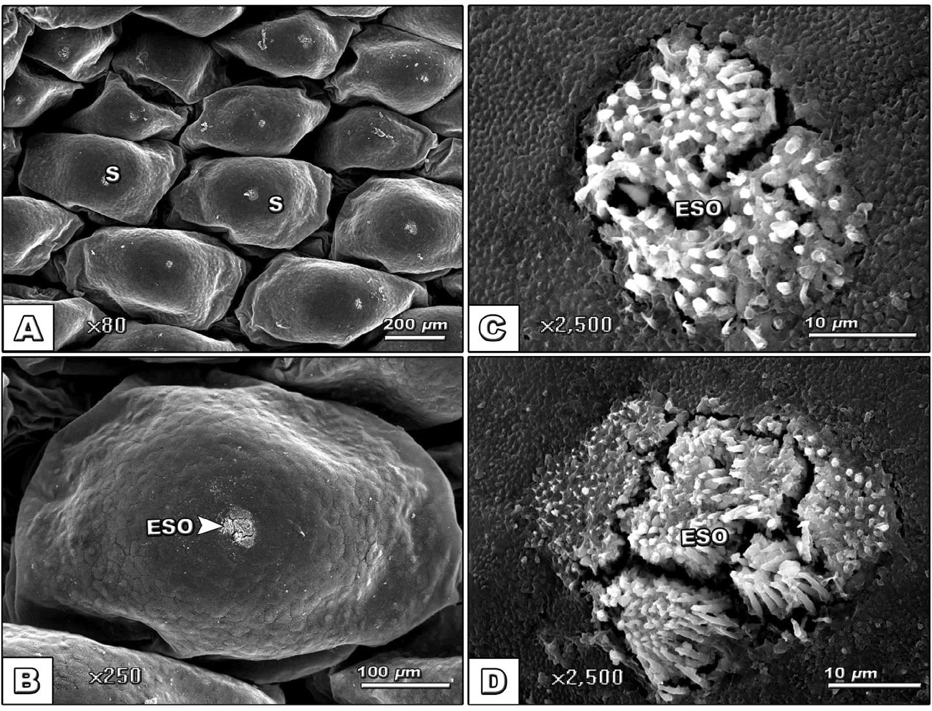

Fig. 2. (A–D): Scanning electron micrograph of dorsal view of skin of stage G3 *Chameleo chameleon* showing oval-shaped overlapping scales. Each one possesses only one central and lenticular sense organ with numerous hairlet-like structures. *Abbreviations*: S, Scale; ESO, Epidermal sense organ.

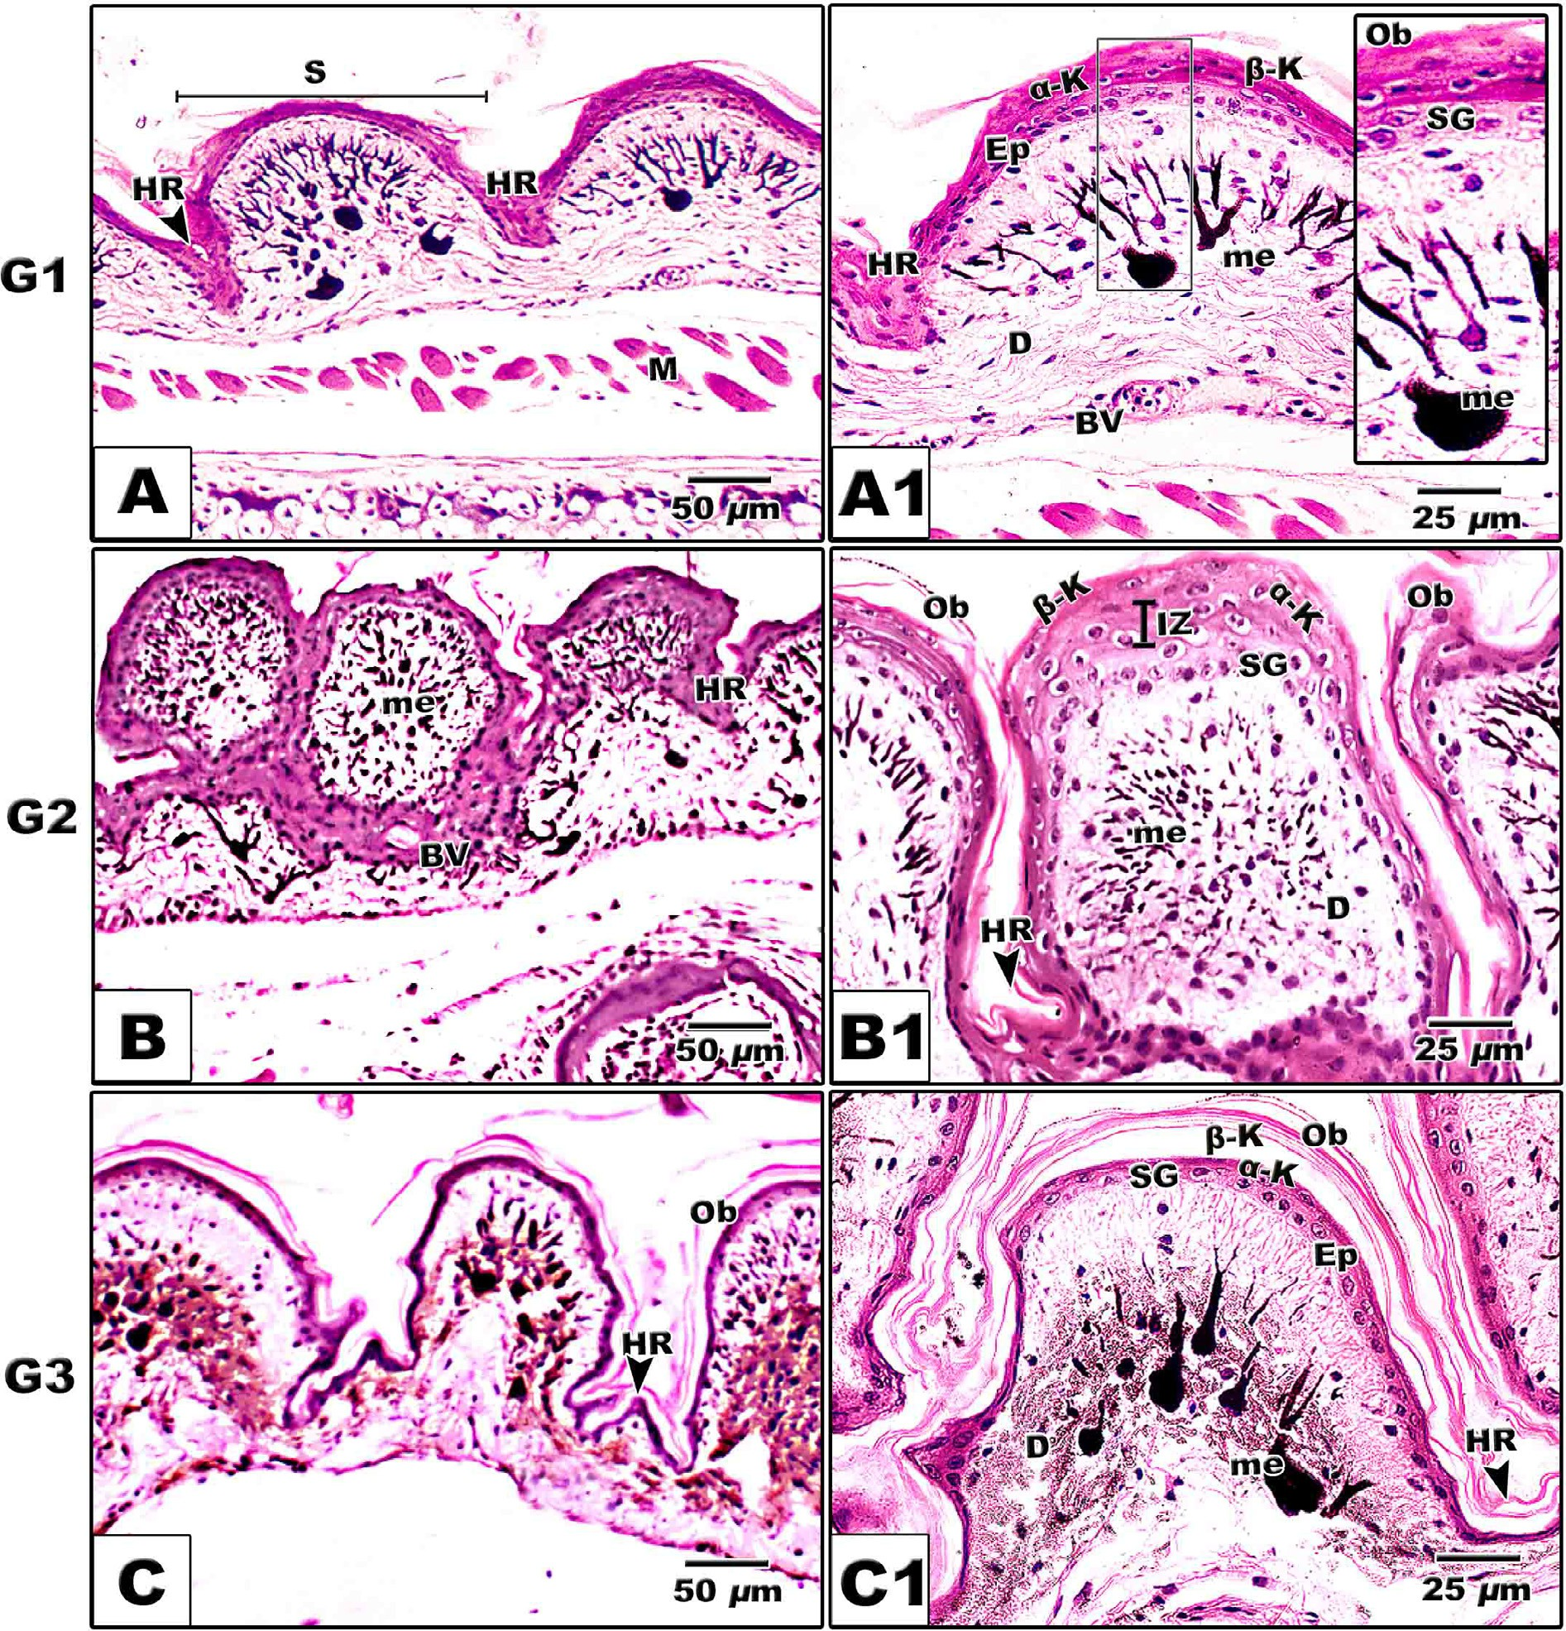

Fig. 3. Photomicrograph of histological sections of skin of different stages of developing *Chameleo chameleon*. A-A1. Stage G1. B-B1. Stage G2. C-C1. Stage G3. The inner most layer of epidermis is cuboidal-shaped cells of the stratum germinativum followed by intermediated zone comprising both stratum spinosum and granulosum, a and b keratin and the outer superficial layer of Oberhaütchen. Laterally, on each side of the scale a distinct thickened hinge region is observed connecting the preceding one. Numerous branched melanophores regularly arranged underneath the epidermis. HX-E. *Abbreviations*: a-K, Alpha-keratin; b-K, Beta keratin; BV, Blood vessel; D, Dermis; Ep, Epidermis; HR, Hing region; IZ, Intermediate zone; me, Melanosomes; Ob, Oberhaütchen; S, Scale; SG, Stratum germinativum.

mostly increased in stage 2 and 3 (Table 2, Fig. 4A–C). Also, Immunohistochemical staining of PCNA revealed highest prolifera- tion and differentiation rate of epidermal cells, fibroblast cells especially in the young age (G1) (Table 2, Fig. 4A1-C1).

* 1. *Transmission electron microscopic observations*

At ultrastructural level, the epidermis is composed of five lay- ers. Basally, germinativum cells having centrally located nuclei with dispersed euchromatin and characteristic nucleoli. Fine kera- tohyalin granules are dispersed in between stratum germinativum cells. The intermediate contains abundant keratinocytes with cyto- plasm rich in keratinohyalin granules. Electron-dense smooth granules of melanosomes are detected in between the ker- atinocytes in the stratum granulosum layer. The epidermal surface

is covered by thickened keratinized layer, the Oberhaütchen (Fig. 5C&D). Underneath the epidermis, numerous mast cells with cytoplasm rich in secretory granules were observed. Bundles of sensory organs are distributed in the dermis and ensheathed with collagenous fibrils. It is composed of myelinated and unmyelinated nerve axons. Two types of neurons are detected. First, oligodendro- cyte appears with peculiar electron-dense nuclear chromatin. The other type, Schwann cell with myelinated axon is observed (Fig. 6A–D).

1. Discussion

The observed dorsum body scales are overlapping with each other and take conical, polygonal and tubercle-shaped structure.

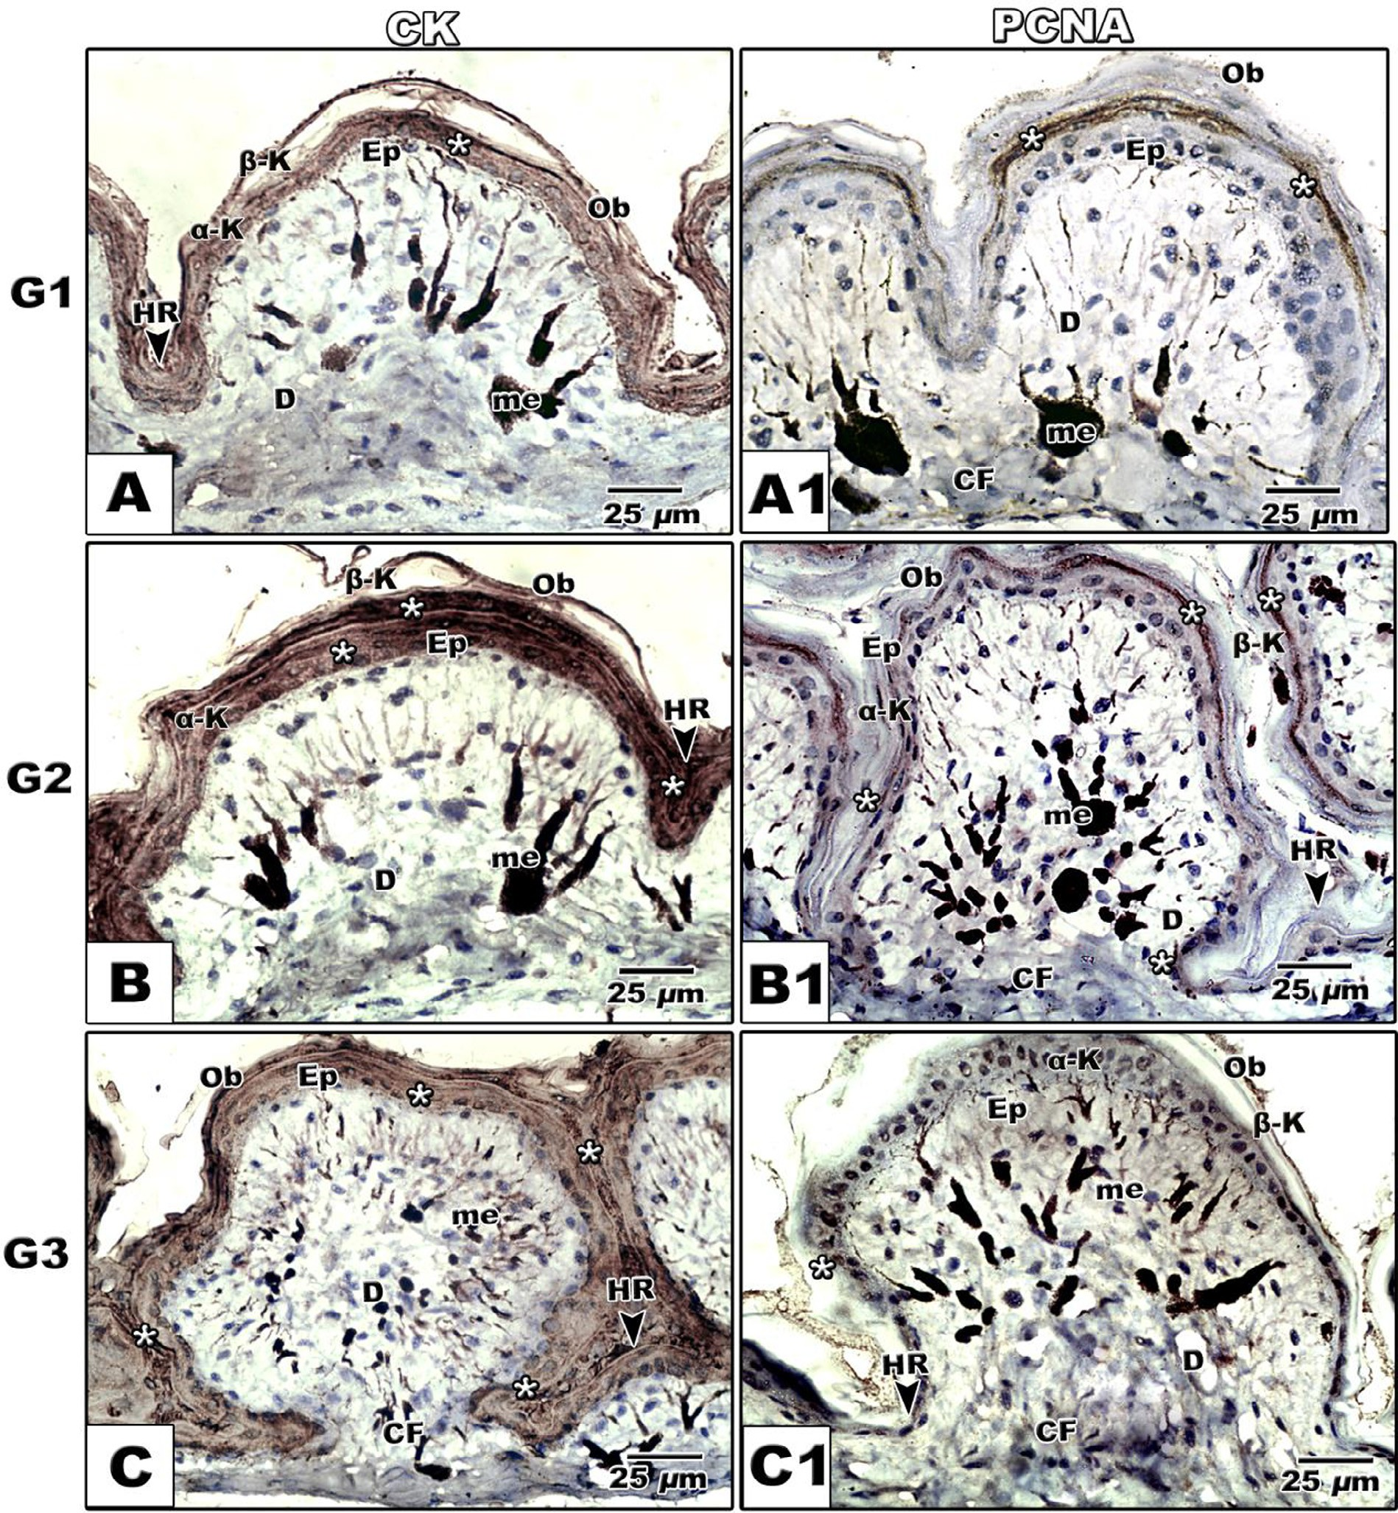

Fig. 4. (A-C2). Photomicrograph of histological sections of skin of *Chameleo chameleon* immunohistochemically stained with anti-CK and anti-PCNA. A&A1. Stage G1. B&B1.

Stage G2. C&C1. Stage G3. A-C. CK immunostaining showing increased cytokeratin staining of Oberhaütchen layer in G2 and G3. A1-C1. PCNA immunostaining showing increased proliferation of epidermal cells and fibroblasts in connective tissue core in G1. *Abbreviations*: *a*-K, Alpha-keratin; *b*-K, Beta keratin; BV, Blood vessel; CF, Collagen

fibers; D, Dermis; Ep, Epidermis; HR, Hing region; me, Melanosomes; Ob, Oberhaütchen.

Developed Oberhaütchen with characteristic a & b keratin make the hardness of epidermal surface. The epidermis is composed of stratum germinativum, intermediate zone of stratum spinosum and granulosum cells, a keratin, b keratin and the superficial Oberhaütchen.

Similar findings were reported in skin of Indian Chameleon (*Chamaeleo zeylanicus*) [17].

Fine keratinohyaline granules are dispersed throughout the epi- dermal cells and characteristic differentiation of Oberhaütchen into a and b keratins. Cornification is highly detected in old ages meanwhile highly proliferated cells are observed in young ages.

Similar findings were reported by Alibardi [18,19] during embry-

onic development in the lizard *Anolis lineatopus*. Development of the Oberhaütchen with characteristic keratinization especially of the outer scale surfaces during early stages reflected the protective barrier and adaptation to the terrestrial life [20].

Abundant distribution of melanosomes is detected in peripheral epidermal layer as well as in collagenous dermal layer underneath the epidermis. The dermal melanophores are characterized by their dendritic arborization. Similar distribution of melanosomes was reported in *Plestiodon latiscutatus* [10].

These melanophores are characteristic pattern of reptilia espe- cially chameleon species facilitating thermoregulation via increas- ing body temperature in cold climate by increasing light

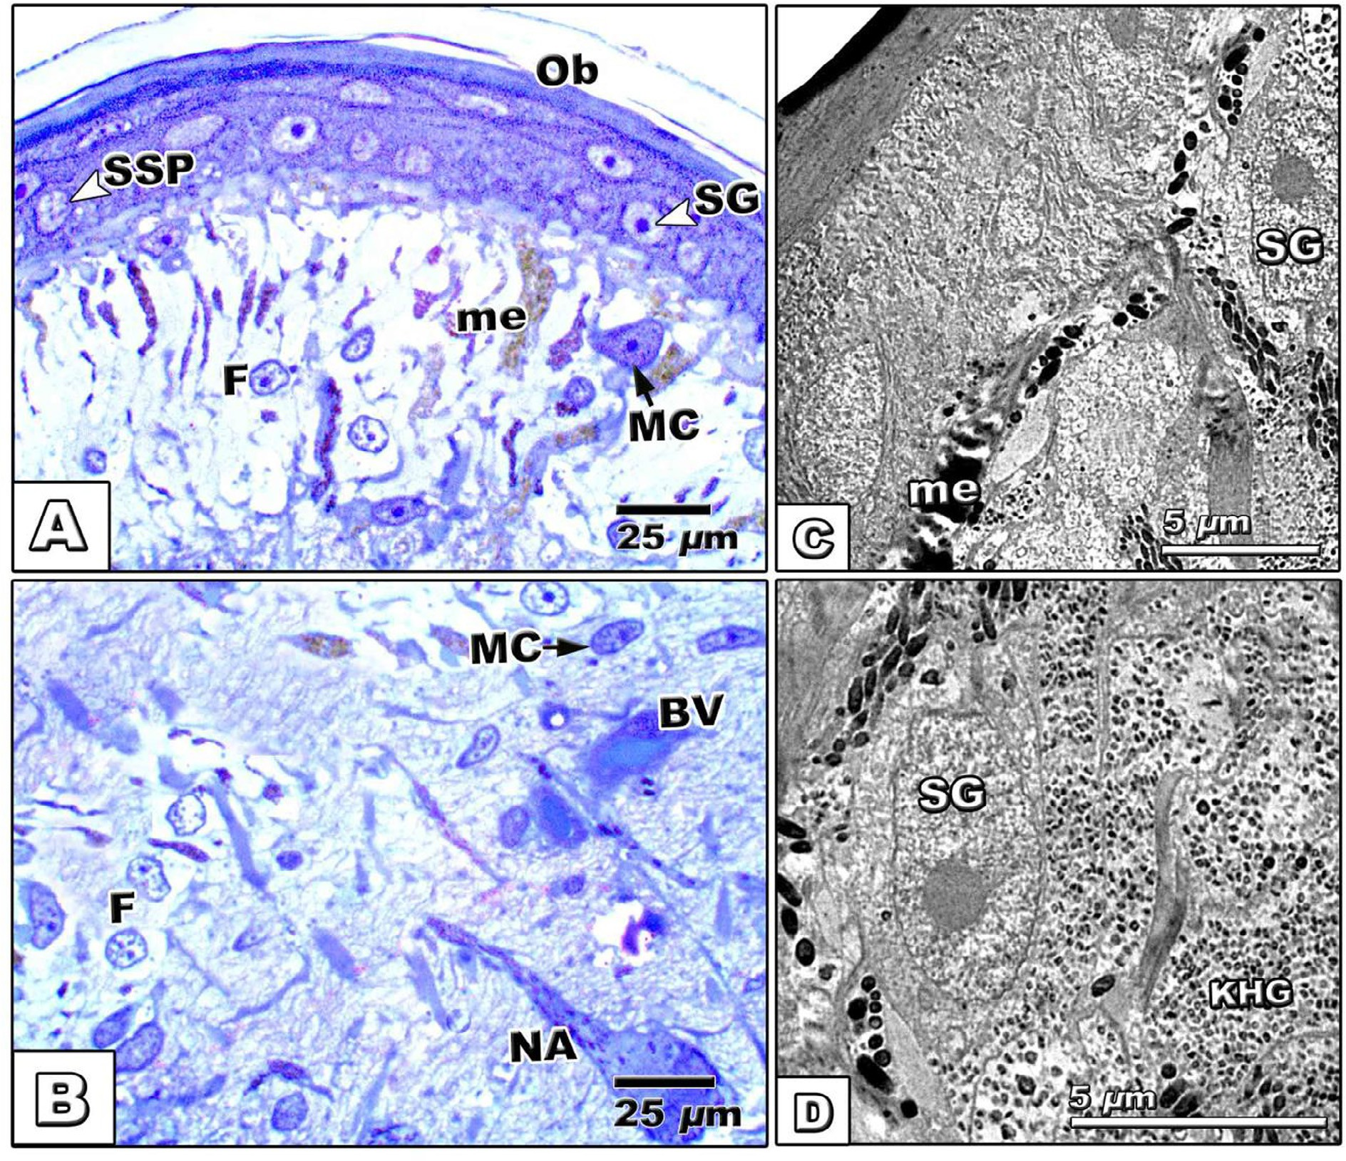

Fig. 5. (A–D). Semithin (A&B) and transmission electron (C&D) micrographs of skin of *Chameleo chameleon*. A&B. Photomicrographs of histological semithin sections of skin of stage G3 showing epidermis with characteristic stratum germinativum, spinosum, granulosum and Oberhaütchen. Note abundant mast cells, fibroblasts, blood vessels and nerve axons in dermis. C&D. Electron micrographs showing epidermis with electron-dense Oberhaütchen and germinativum cells (A) and abundant large spherical electron- dense melanin granules in dermis underneath the epidermis. Note the presence of melanosomes surrounding the germinativum cell. *Abbreviations*; BV, Blood vessel; F, Fibroblast; MC, Mast cell; me, Melanosomes; Ob, Oberhaütchen; SG, Stratum germinativum; SSP, Stratum spinosum; NA, Nerve axon.

|  |  |  |  |  |  |  |  |  |  |  |
| --- | --- | --- | --- | --- | --- | --- | --- | --- | --- | --- |
| Table 2  Immunoreactivity of CK and PCNA of skin of | *Chameleo chameleon.* |  | | | | | | | | |
|  |  | G1 |  |  | G2 |  |  | G3 |  |  |
|  |  | CK | PCNA |  | CK | PCNA |  | CK | PCNA |  |
| Epidermis | SB | — | — |  | + | + |  | + | — |  |
|  | SSP | — | — |  | + | — |  | ++ | — |  |
|  | SG | + | + |  | ++ | ++ |  | +++ | — |  |
|  | Ob | + | +++ |  | ++ | + |  | +++ | + |  |
| Epidermal-dermal junction |  | — | + |  | — | — |  | ++ | — |  |
| Dermis |  | — | — |  | — | — |  | + | — |  |

Abbreviations; CK, cytokeratin; Ob, Oberhaütchen; PCNA, Proliferating cell nuclear antigen; SB, stratum basale, SG, stratum granulosum; SSP, Stratum spinosum —, Negative immunoreaction; +, Weak immunoreaction; ++, Moderate immunoreaction; +++, Intense immunoreaction.

penetration across the skin [21] as well as production of various coloring of reptiles skin [22].

Light and ultrastructural observations revealed abundant distri- bution of mast cells. Mast cells is highly important for the chame- leon species due to its secretion of peptidases such as tryptases, chymases, carboxypeptidase A3, and dipeptidylpeptidase I (cathepsin C) which is responsible for host defense and homeosta- sis [23].

Immunohistochemical staining with cytokeratin show increased reaction in different epidermal layers in stage 2 and 3. Meanwhile, the immunoreaction of PCNA revealed highest prolif- eration and differentiation rate of epidermal cells in the young age (G1).

Alibardi [24] observed an increase in the three different anti- cytokeratins (a-keratin) in the epidermis of lizard epidermis of the lizard *Podarcis sicula*. Also, our results were consistent with

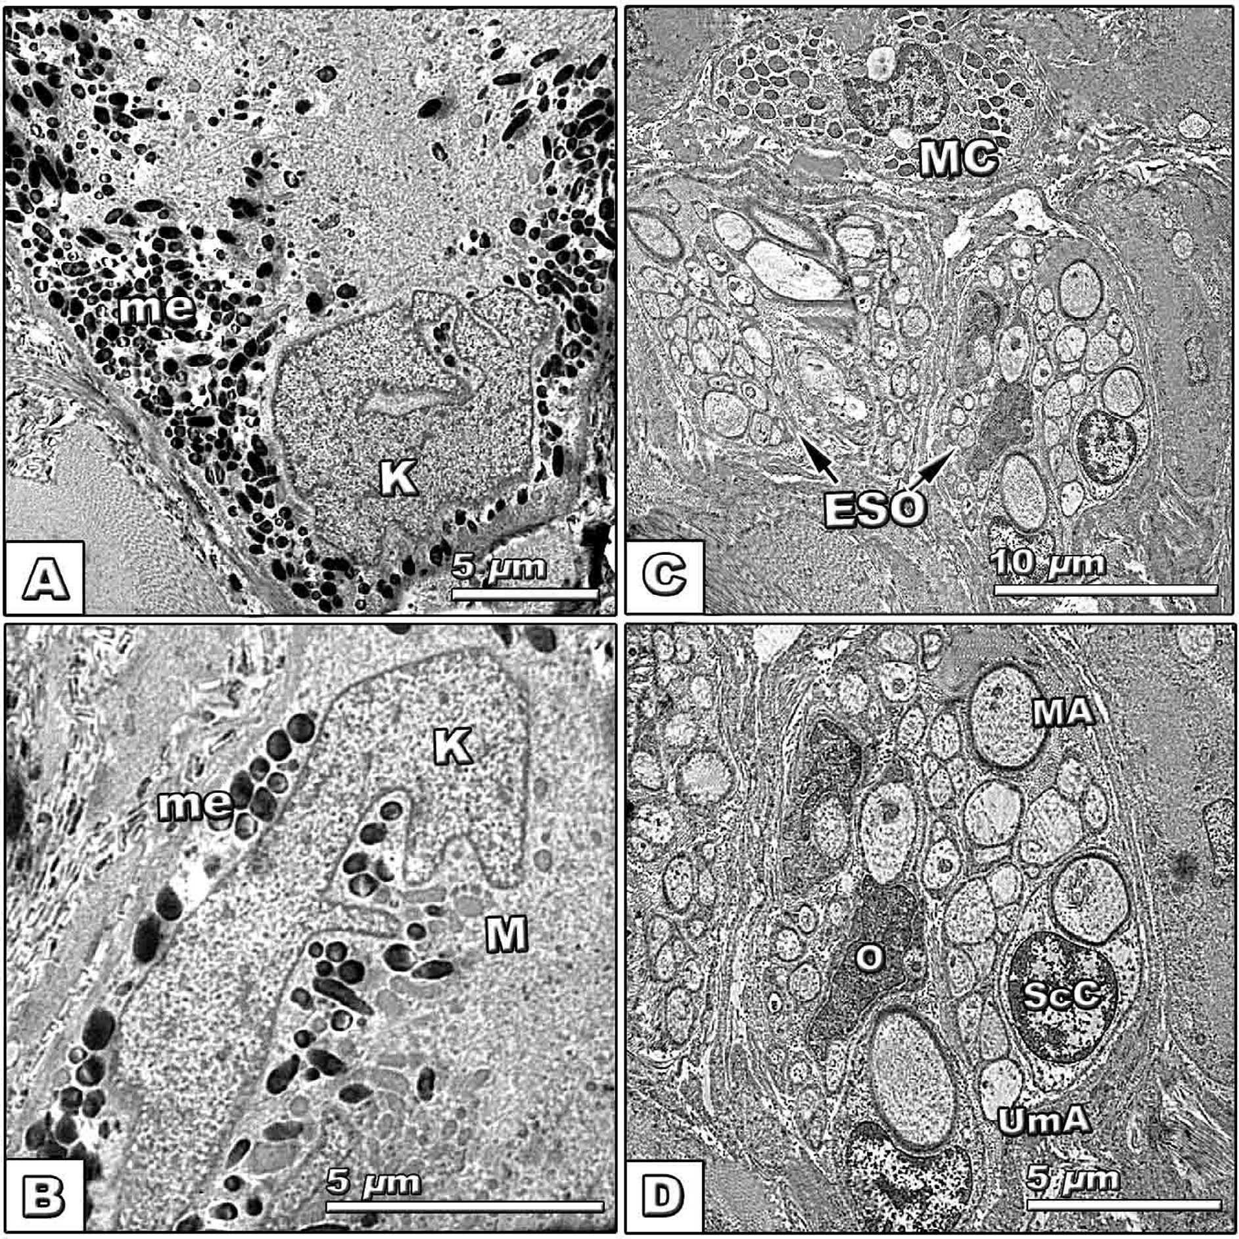

Fig. 6. (A–D). Transmission electron (C&D) micrographs of G3 skin of *Chameleo chameleon*. A&B. Showing Keratinocytes with convoluted nuclear envelope and cytoplasm rich in keratohyalin granules. C&D. Showing mast cells widespread in between integumentary sense organs outlined by then collagenous sheath and composed of Schwvann cell with unmyelinated axons, oligodendrocytes and myelinated axons. *Abbreviations*: ESO, Epidermal sense organ; K, Keratinocyte; M, Mitochondria; MA, myelinated axon; MC, Mast cell; me, Melanosomes; O, oligodendrocyte; ScC, Schwann cell; UmA, unmyelinated axon.

Di-Poï and Milinkovitch [25] who reported an increase in cell pro- liferation rate in the dermo-epidermal elevation that generates the scales in lizards and snakes.

A stricking finding is the presence of a single epidermal sense organ per each dorsal body scale. The sense organs takes the lenticular-shape possess dense sensory hairlet-structures bearing bristles. Several studies reported similar sense organs although the emerging sensory hairlet structures are very few such as, *Oplu- rus fierinensis* [26], *Amphibolurus barbatus* [12], *Ceratophora, Draco*, *Phrynocephalus, Stellio*, and *Trapelus* (agamids) and in *Anolis, Chal- arodon* and *Oplurus iguanids* [13] and *Stenodactylus Petrii* and *Ptyo- dactylus Guttatus* [27].

de Haan [28] studied several kinds of snakes such as *D. lineatus*,

*M. monspessulanus and R. rubropunctatus* and reported the presence of cephalic epidermal sense organs on their upper head and serve for enabling correct skin during molting.

According to Ananjeva et al. [13] epidermal sense organs are important for serving mechanical and thermoreceptors and possi- bly sensitive to the humidity.

Furthermore, for the first to remarks, the epidermal sense organs have deep connections with integumentary sense organs embedded in the dermal layer. Ultrastructurally, it is appeared in the form oval-shaped bundles covered by a thin coat of collagenous fibrils. It is composed of two types of neurons including Schwann and oligodendrocyte cells. Myelinated and unmyelinated nerve axons are detected.

Similar findings of light microscopic observations were reported during embryogenesis of crocodile which serve as chemo- and thermosensory transduction channels [29].

Finally, the author concluded that the juvenile chameleon skin is keratinized with obvious external and internal sensation and abundant mast cells within dermis giving characteristic immunity.

The melanosomes are dispersed within epidermis and dermis allowing the animal to maintain its color alterations according to the surrounding environment.

References

1. [Matoltsy G, Bereiter-Hahn J. Biology of the integument. Introduction. In:](http://refhub.elsevier.com/S2314-808X(16)30144-0/h0005) [Bereiter-Hahn J, editor. Matoltsy of the integument. Berlin: Springer-Verlag;](http://refhub.elsevier.com/S2314-808X(16)30144-0/h0005) [1986. p. 1–7](http://refhub.elsevier.com/S2314-808X(16)30144-0/h0005).
2. [Pough FH, Janis CM, Heiser JB. Vertebrate life. 9th ed. Boston: Pearson; 2013](http://refhub.elsevier.com/S2314-808X(16)30144-0/h0010).
3. [Pough F, Andrews R, Cadle J, Crump M, Savitzky A, Wells K. Herpetology. Upper](http://refhub.elsevier.com/S2314-808X(16)30144-0/h0015) [Saddle River, NJ, USA: Prentice-Hall; 2001](http://refhub.elsevier.com/S2314-808X(16)30144-0/h0015).
4. [Jensen-Jarolim E. Comparative medicine: anatomy and physiology. Springer](http://refhub.elsevier.com/S2314-808X(16)30144-0/h0020) [Science & Business Media; 2013](http://refhub.elsevier.com/S2314-808X(16)30144-0/h0020).
5. [Allam AA, Daza JD, Abo Eleneen RE. Histology of the skin of three limbless](http://refhub.elsevier.com/S2314-808X(16)30144-0/h0025) [squamates dwelling in mesic and arid environments. Anat Rec (Hoboken)](http://refhub.elsevier.com/S2314-808X(16)30144-0/h0025) [2016;299(7):979–89](http://refhub.elsevier.com/S2314-808X(16)30144-0/h0025).
6. [Alibardi L. Adaptation to the land: The skin of reptiles in comparison to that of](http://refhub.elsevier.com/S2314-808X(16)30144-0/h0030) [amphibians and endotherm amniotes. J Exp Zool B Mol Dev Evol 2003;298](http://refhub.elsevier.com/S2314-808X(16)30144-0/h0030) [(1):12–41](http://refhub.elsevier.com/S2314-808X(16)30144-0/h0030).
7. [Alibardi L, DeNardo DF. Ultrastructural and immunocytochemical features of](http://refhub.elsevier.com/S2314-808X(16)30144-0/h0035) [the epidermis of the lizard Heloderma suspectumindicate richness in lipids](http://refhub.elsevier.com/S2314-808X(16)30144-0/h0035) [and lack of a specialized shedding complex. Acta Zool (Stockholm) 2011;94](http://refhub.elsevier.com/S2314-808X(16)30144-0/h0035) [(1):35–43](http://refhub.elsevier.com/S2314-808X(16)30144-0/h0035).
8. [Hogan MB, Peele K, Wilson NW. Skin barrier function and its importance at the](http://refhub.elsevier.com/S2314-808X(16)30144-0/h0040) [start of the atopic march. J Allergy (Cairo) 2012;2012](http://refhub.elsevier.com/S2314-808X(16)30144-0/h0040).
9. [Bagnara JT, Matsumoto J. Comparative anatomy and physiology of pigment](http://refhub.elsevier.com/S2314-808X(16)30144-0/h0045) [cells in non mammalian tissues. In: Nordlung JJ, Boissy RE, Hearing VJ, King RA,](http://refhub.elsevier.com/S2314-808X(16)30144-0/h0045) [Ortonne JP, editors. The pigmentary system. Oxford, UK: Blackwell; 2006. p.](http://refhub.elsevier.com/S2314-808X(16)30144-0/h0045) [11–60](http://refhub.elsevier.com/S2314-808X(16)30144-0/h0045).
10. [Kuriyama T, Miyaji K, Sugimoto M, Hasegawa M. Ultrastructure of the dermal](http://refhub.elsevier.com/S2314-808X(16)30144-0/h0050) [chromatophores in a lizard (Scincidae: *Plestiodon latiscutatus*) with](http://refhub.elsevier.com/S2314-808X(16)30144-0/h0050) [conspicuous body and tail coloration. Zoolog Sci 2006;23(9):793–9](http://refhub.elsevier.com/S2314-808X(16)30144-0/h0050).
11. [Bagnara JT. Developmental aspects of vertebrate chromatophores. Am Zool](http://refhub.elsevier.com/S2314-808X(16)30144-0/h0055) [1983;23:465–78](http://refhub.elsevier.com/S2314-808X(16)30144-0/h0055).
12. [Maclean S. Ultrastructure of epidermal sensory receptors in *Amphbolurus*](http://refhub.elsevier.com/S2314-808X(16)30144-0/h0060)[*barbatus* (Lacertlia, Agamidae). Cell Tissue Res 1980;210:435–45](http://refhub.elsevier.com/S2314-808X(16)30144-0/h0060).
13. [Ananjeva WB, Dilmuchamedov ME, Matevyeva TN. The skin sense organs of](http://refhub.elsevier.com/S2314-808X(16)30144-0/h0065) [some Iguanian lizards. J Herpetol 1991;25(2):186–99](http://refhub.elsevier.com/S2314-808X(16)30144-0/h0065).
14. [Jackson MK, Doetsch GS. Functional properties of nerve fibers innervating](http://refhub.elsevier.com/S2314-808X(16)30144-0/h0070) [cutaneous corpuscles within cephalic skin of the Taxas rat snake. J Exp Neurol](http://refhub.elsevier.com/S2314-808X(16)30144-0/h0070) [1976;56:63–77](http://refhub.elsevier.com/S2314-808X(16)30144-0/h0070).
15. [Von Düring M, Miller MR. Sensory nerve ending of the skin and deeper](http://refhub.elsevier.com/S2314-808X(16)30144-0/h0075) [structures. In: Gans IC, editor. Biology of the reptilian, vol. 19. New](http://refhub.elsevier.com/S2314-808X(16)30144-0/h0075) [York: Academic press; 1979. p. 407–41](http://refhub.elsevier.com/S2314-808X(16)30144-0/h0075).
16. Crowe-Riddell JM, Snelling EP, Watson AP, Suh AK, Partridge JC, Sanders KL. The evolution of scale sensilla in the transition from land to sea in elapid snakes. Open Biol 2016;6(6). <http://dx.doi.org/10.1098/rsob.160054>.
17. [Nissar S, Basha SH, Ramesh G, Venkatesan S, Allwin B. Gross and](http://refhub.elsevier.com/S2314-808X(16)30144-0/h0085) [histomorphology of the skin of the Indian Chameleon (*Chamaeleo zeylanicus*).](http://refhub.elsevier.com/S2314-808X(16)30144-0/h0085) [Ind J Vet Anat 2016;28(1):47–8](http://refhub.elsevier.com/S2314-808X(16)30144-0/h0085).
18. [Alibardi L. Scale morphogenesis during embryonic development in the lizard](http://refhub.elsevier.com/S2314-808X(16)30144-0/h0090)

[*Anolis lineatopus*. J Anat 1996;188:713–25](http://refhub.elsevier.com/S2314-808X(16)30144-0/h0090).

1. [Alibardi L. Differentiation of the epidermis during scale formation in embryos](http://refhub.elsevier.com/S2314-808X(16)30144-0/h0095) [of lizard. J Anat 1998;192:173–86](http://refhub.elsevier.com/S2314-808X(16)30144-0/h0095).
2. [Chang C, Wu P, Baker RE, Maini PK, Alibardi L, Chuong CM. Reptile scale](http://refhub.elsevier.com/S2314-808X(16)30144-0/h0100) [paradigm: Evo-Devo, pattern formation and regeneration. Int J Dev Biol](http://refhub.elsevier.com/S2314-808X(16)30144-0/h0100) [2009;53(5–6):813–26](http://refhub.elsevier.com/S2314-808X(16)30144-0/h0100).
3. [Francois BL, Richard B. The chamelon handbook. 3rd ed. New York: Barron’s](http://refhub.elsevier.com/S2314-808X(16)30144-0/h0105) [Educational Series; 2009](http://refhub.elsevier.com/S2314-808X(16)30144-0/h0105).
4. [Teyssier J, Saenko VS, Marel DV, Milinkovitch MC. Photonic crystals cause](http://refhub.elsevier.com/S2314-808X(16)30144-0/h0110) [active colour change in chameleons. Nat Commun 2015;6:63–8](http://refhub.elsevier.com/S2314-808X(16)30144-0/h0110).
5. [Trivedi NN, Caughey GH. Mast cell peptidases chameleons of innate immunity](http://refhub.elsevier.com/S2314-808X(16)30144-0/h0115) [and host defense. Am J Respir Cell Mol Biol 2010;42:257–67](http://refhub.elsevier.com/S2314-808X(16)30144-0/h0115).
6. [Alibardi L, Maurizii M, Taddei C. Immunocytochemical and electrophoretic](http://refhub.elsevier.com/S2314-808X(16)30144-0/h0120) [distribution of cytokeratins in the resting stage epidermis of the lizard](http://refhub.elsevier.com/S2314-808X(16)30144-0/h0120) [Podarcis sicula. J Exp Zool 2001;289(7):409–18](http://refhub.elsevier.com/S2314-808X(16)30144-0/h0120).
7. [Di-Poï N, Milinkovitch MC. The anatomical placode in reptile scale](http://refhub.elsevier.com/S2314-808X(16)30144-0/h0125) [morphogenesis indicates shared ancestry among skin appendages in](http://refhub.elsevier.com/S2314-808X(16)30144-0/h0125) [amniotes. Sci Adv 2016;2:e1600708](http://refhub.elsevier.com/S2314-808X(16)30144-0/h0125).
8. [Williams EE. A new look at the Iguania. In: Vanzolini PE, Heyer WR, editors.](http://refhub.elsevier.com/S2314-808X(16)30144-0/h0130) [Proc. workshop on neotropical distribution patterns. Academy Brasil Clien Rio](http://refhub.elsevier.com/S2314-808X(16)30144-0/h0130) [de Janeiro; 1988. p. 429–88](http://refhub.elsevier.com/S2314-808X(16)30144-0/h0130).
9. [Darwish ST. Comparative light and ultrastructural studies of skin in](http://refhub.elsevier.com/S2314-808X(16)30144-0/h0135) [*Stenodactylus Petrii* and *Ptyodactylus Guttatus* (Reptilia: Gekonidae). Egy J Exp](http://refhub.elsevier.com/S2314-808X(16)30144-0/h0135) [Biol (Zool.) 2012;8(1):9–14](http://refhub.elsevier.com/S2314-808X(16)30144-0/h0135).
10. [de Haan CC. Sense-organ-like parietal pits found in Psammophiini (Serpentes,](http://refhub.elsevier.com/S2314-808X(16)30144-0/h0140) [Colubridae). CR Biol 2003;2003(326):287–93](http://refhub.elsevier.com/S2314-808X(16)30144-0/h0140).
11. [Di-Poï N, Milinkovitch MC. Crocodylians evolved scattered multi-sensory](http://refhub.elsevier.com/S2314-808X(16)30144-0/h0145) [micro-organs. Evo Devo 2013;4(1):19](http://refhub.elsevier.com/S2314-808X(16)30144-0/h0145).